##### FORECASTING OF ELECTRICITY PRICES

##### PROJECT REPORT

###### ***Submitted by***

##### Arpan Sadhukhan (10000219022)

Debjit Sarkar (1000219059)

Srijan Dutta (10000219075)

***Supervised by***

**Dr. Sayani Mondal**

***in partial fulfillment for the award of the degree of***

##### Bachelor of Technology

in

**Information Technology**

**Year:2019-2023**



**Maulana Abul Kalam Azad University of Technology**

**Haringhata, Nadia,**

**West Bengal**

**PIN-741249**

**BONAFIDE CERTIFICATE**

Certified that this project report **“Forecasting of Electricity Prices”**

is the bonafide work of “**Arpan Sadhukhan”, “Debjit Sarkar”, “Srijan Dutta”** who carried out the project work under my supervision.

**SIGNATURE SIGNATURE**

**Dr. Somdatta Charkaborty**   **Dr. Sayani Mondal**

HEAD OF THE DEPARTMENT SUPERVISOR

Dept. of Information Technology Assistant Professor,

Dept. of Emerging Technologies

MAKAUT, WB MAKAUT, WB

**SIGNATURE**

**External Examiner:**

**Table of Content**

|  |  |  |
| --- | --- | --- |
| **Chapter No**. | **Title** | **Page No.** |
| 1. | Introduction | 4 |
| 2. | Literature Study | 5 |
| 3. | Motivation | 6 |
| 4. | Objective | 7 |
| 5. | Methodology | 8 |
| 6. | Data Collection | 9 |
| 7. | Data Statistics | 10 |
| 8. | Data Visualization | 12 |
| 9. | SVM | 15 |
| 10. | Steps to be done | 16 |
| 11. | Work to be done | 17 |
| 12. | References | 18 |

**Introduction**

The future of the world power industry is focused on the reform of the power market and the development of new technologies. The reform of the power market will help to improve efficiency and reduce costs, while the development of new technologies will help to meet the increasing demand for electricity and reduce greenhouse gas emissions. Accurate electricity price forecasting is essential for market participants to make informed decisions. The unique characteristics of electricity and the uncertainty of market and bidding strategies make electricity price forecasting more complex than power load forecasting. Electricity price forecasting is the process of predicting future electricity prices. This is an important task for energy market participants, as it can help them make informed decisions about their energy consumption and trading activities.

There are a number of different methods that can be used for electricity price forecasting. Some of the most common methods include:

1. Time series analysis: This method uses historical data to predict future prices.
2. Econometric models: These models use economic factors, such as demand and supply, to predict future prices.
3. Machine learning models: These models use artificial intelligence to learn from historical data and predict future prices.

The best method for electricity price forecasting will vary depending on the specific situation. For example, time series analysis may be a good choice for short-term forecasting, while econometric models may be a better choice for long-term forecasting.

This project focuses on predicting day ahead electricity prices in India using time-series analysis and ML models. We used Support Vector Machine (SVM), Auto Regression Integrated Moving Average (ARIMA) model and Long Short-Term Memory (LSTM) to predict prices.

The accuracy of electricity price forecasts can vary depending on a number of factors, including the quality of the data used, the method used for forecasting, and the time horizon of the forecast. Electricity price forecasting is a complex task, and there is no single method that is always the best. Electricity price forecasting can be a valuable tool for energy market participants, as it can help them make informed decisions about their energy consumption and trading activities.

**Literature Study**

Electricity price forecasting is a crucial aspect of the energy industry as it enables stakeholders to make informed decisions about investments, operations, and energy consumption. In India, the electricity market is rapidly growing, and accurate price forecasting is critical for stakeholders to optimize their operations and maximize their returns. In this literature study, we will review some of the recent research on electricity price forecasting in India.

|  |  |  |
| --- | --- | --- |
| **Year of Publication** | **Paper Name** | **Summary** |
| 2022 | Data-driven modelling for long-term electricity price forecasting [10]. | The suggested approach demonstrated in the study is capable of anticipating the most important changes in the price of power; and generalization by capturing the operating principles of often electricity markets. These results illustrate the possibilities for hybrid data-driven and market-based models and support the relevance and validity of data-driven, precisely resolved, long-term predictions. |
| 2021 | Long-term forecasting model for future electricity consumption in French non-interconnected territories [4]. | Thesis focuses on the long-term forecasting of hourly electricity demand. Historical data are first analyzed through a clustering analysis to identify trends and patterns, based on a k-means clustering algorithm. Generalized additive model, a relatively new model in the energy forecasting field, gives promising results. |
| 2020 | Comparison of Various Machine Learning Algorithms for Predicting Energy Price in Open Electricity Market [5]. | This research focuses on investigating the potential for energy price prediction using several machine learning (ML) techniques. Using four alternative algorithms—Simple Linear Regression, Support Vector Machines (SVM), K Nearest Neighbor, and Long Short-Term Memory—this work focuses on investigating the viability of predicting the energy price in the open electricity market. This work's key contribution is the creation of a machine learning (ML) system that can forecast future pricing. |
| 2020 | PSO–LSTM for short term forecast of heterogeneous time series electricity price signals [3]. | Deep neural network is the best model for learning the non-linear behavior of the data and for the purpose of forecasting. Long-term forecasting is not viable as there is uncertainty in the forecast due to increasing integration of renewable sources with the existing grids. Particle swarm optimization technique is used to optimize the LSTM network input weights, which in turn minimize the forecast error. |
| 2020 | Energy price prediction using data-driven models: A decade review [9]. | The orientation of the energy market depends on the precision of price predictions, which can serve as a guide for market participants and regulators. This paper offers a comprehensive decade-by-decade assessment of data-driven models for predicting energy prices. Natural gas, crude oil, electricity, and carbon are the four different types of energy costs. The primary contributions and findings are basic energy price prediction models, data cleansing techniques, and optimizer are categorized and described. |
| 2019 | A time varying approach on the price elasticity of electricity in India during 1975-2013 [7]. | The study concludes that macroeconomic factors like trade and foreign direct investment have an impact on the demand for electricity. This study focuses on issues for both public policy makers and commercial investors that want to fund infrastructure and utilities related to power supply. When compared to other research, the value of the projected elasticity in the current study is considerably lower, which, among other things, reflects the fact that India's energy demand is supply driven. |
| 2018 | A hybrid electricity price forecasting model with Bayesian optimization for German energy exchange [2]. | Hybrid method, with using empirical wavelet transform (EWT), support vector regression (SVR), Bi-directional long short-term memory (BiLSTM) and Bayesian optimization (BO), is proposed to increase the accuracy of electricity price forecasting. Five different case studies are adopted to verify the effectiveness of BO, EWT and hybrid model respectively. |
| 2017 | Sequential wavelet-ANN with embedded ANN-PSO hybrid electricity price forecasting model for Indian energy exchange. [8] | To estimate the market clearing price (MCP) for the short-term day ahead in the Indian energy exchange, this study offers a novel sequential wavelet-artificial neural network (ANN) with embedded ANN-particle swarm optimisation (PSO). The feed-forward back-propagation neural network is trained using the historical data, namely purchase bid and MCP. Three phases are sequentially including a wavelet transform approach is used to first smooth out the raw historical data by removing the high-frequency components, which may improve neural network training. The next step is to train historical patterns using ANN. The recorded weights from the numerous trials are used as the initial population for the embedded ANN-PSO model in the final phase. |
| 2015 | Midterm Electricity Market Clearing Price Forecasting Using Two-Stage Multiple Support Vector Machine [1] | The electricity market clearing price (MCP) is essential for maintenance scheduling, planning, bilateral contracting, resources reallocation, and budgeting. A two-stage multiple support vector machine (SVM) based midterm forecasting model of the electricity MCP is proposed. Compared to the forecasting model using a single SVM, the proposed model showed improved forecasting accuracy in both peak prices and overall system. |

**Few observations can be listed from the earlier studies of electricity forecasting using MCP value includes the following: Authors have conducted the studies using different machine learning, statistical or hybrid models each for the short-, mid- or long-term forecasting. A single model has not been used for short-, mid- or long-term forecasting analysis. The primary contribution of this study is to understand how a single model behaves with different range of data for short, mid, and long term. Thus, the traditional statistical time variant model ARIMA has been considered in this study.** Overall, these studies highlight the importance of accurate electricity price forecasting in the Indian electricity market and propose various forecasting methods that can improve the accuracy of forecasts. However, further research is needed to address the challenges of data availability and the variability of demand and supply in the Indian energy market.

**Motivation**

The future development of the world power industry is focused on the reform of power marketization. The main content of the reform is to compete in different levels of power generation, transmission, distribution, and sales. Electricity prices affect the operation of the entire electricity market and are extremely important to every market participant. Each participant trades in the electricity market based on the price of electricity. In the market competition, if the electricity price is accurately predicted in advance, it can be in a favorable position to obtain more benefits. However, due to the unique characteristics of electricity and the uncertainty of market and bidding strategies, electricity price forecasts have become more complex than power load forecasting.

Predicting electricity prices is a critical task for market participants, as it can help them make informed decisions about their energy consumption and trading activities. Accurate electricity price predictions can help market participants to:

* Make better decisions about when to buy and sell electricity.
* Reduce their risk of exposure to volatile prices.
* Optimize their energy portfolio.
* Improve their profitability.

The accuracy of electricity price forecasts can vary depending on a number of factors, including the quality of the data used, the method used for forecasting, and the time horizon of the forecast. However, there are a number of methods that can be used to improve the accuracy of electricity price forecasts, including:

* Using historical data to train a forecasting model.
* Incorporating economic factors, such as demand and supply, into the forecasting model.
* Using machine learning algorithms to learn from historical data and predict future prices.

The development of new technologies, such as artificial intelligence, is opening up new possibilities for improving the accuracy of electricity price forecasts. By using these new technologies, market participants can gain a competitive advantage and make better decisions about their energy consumption and trading activities.

The motivation for this study is to develop a forecasting model that can accurately predict electricity prices for different time horizons. The proposed model uses an autoregressive integrated moving average (ARIMA) model, which is a statistical model that can be used to forecast time series data. The model was trained on historical data from the Indian electricity market and was tested on out-of-sample data. The results of the study showed that the proposed model was able to accurately predict electricity prices for different time horizons.

The findings of this study have important implications for market participants. By using the proposed model, market participants can gain a competitive advantage and make better decisions about their energy consumption and trading activities.

**Objectives**

The objective of this project is to develop a comprehensive forecasting model for the electricity market in the West Bengal, Sikkim, Bihar, Jharkhand, and Odisha regions, focusing on medium-term and long-term forecasts. The project aims to utilize day-ahead prices and historical data to forecast the Market Clearing Price (MCP) in the deregulated electricity market. The forecasting will be conducted for three-time horizons: short term (3 months), medium term (6 months), and long term (1 year).

The project will involve the following key components:

1. Data Collection: Gather historical electricity market data, including day-ahead prices and any other relevant factors that can influence the electricity market.
2. Model Development: Develop robust ML forecasting models that utilize the collected data to forecast the Market Clearing Price for the specified time horizons.
3. Validation and Refinement: Validate the forecasting models using historical data and performance evaluation metrics. Refine the models as necessary to improve accuracy and reliability.
4. Regional Focus: Pay specific attention to the West Bengal, Sikkim, Bihar, Jharkhand, and Odisha regions, taking into account their unique characteristics, electricity demand patterns, regulatory frameworks, and market conditions.
5. Medium-Term and Long-Term Forecasting: Develop forecasting models that are capable of providing accurate medium-term (6 months) and long-term (1 year) forecasts of the Market Clearing Price.
6. Documentation and Reporting: Document the methodologies, assumptions, and findings of the forecasting models. Prepare comprehensive reports outlining the forecasted Market Clearing Prices for different time horizons and regions.

By achieving these project objectives, the forecasting model will provide valuable insights into the Market Clearing Price trends and dynamics, empowering market participants in the West Bengal, Sikkim, Bihar, Jharkhand, and Odisha regions to optimize their operations, mitigate risks, and make informed decisions in the deregulated electricity market.

**Data Collection & Methodology**

The first step in predicting electricity prices is to gather historical data. We collected hourly electricity prices for the year 2021 from the India Energy Exchange (IEX) website(<https://www.iexindia.com/marketdata/areaprice.aspx>).

The data covers the period from January 2021 to December 2021. The dataset holds over 8,760 hourly observations of electricity prices, including weekends and holidays. The dataset has been considered in three different ways for analysis in different ways such as short term (typically which ranges from 1 hour to 1 week), mid-term (typically which ranges from 1 week to 1 year) and Long-term (more than a year). In this study, each category of time has been considered as shown in Table 1.

**Dataset Details**

|  |  |  |  |
| --- | --- | --- | --- |
| **Term** | **Date** | **Time** | **Dataset Statistics (Rows)** |
| Short-term | 3 months | January’21 - March’21 | 2160 |
| Mid-term | 6 months | January’21 - June’21 | 4344 |
| Long-term | 12 months | January’21 - December’21 | 8760 |

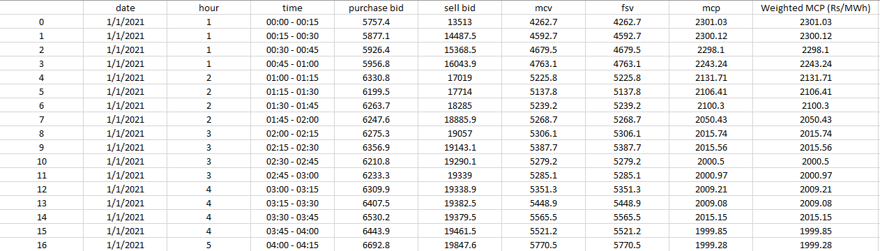

Sample Dataset

**APPROACH:**

Mid-term electricity market clearing price forecasting using Multiple support Vector Machine:

Data Collection

Data Pre-processing

Applying ARIMA Model

Applying LSTM Model

Applying Support Vector Machine (SVM)

Data Validation

Accuracy Prediction

**Definition of Attributes Considered:**

**Purchase Bid:** A purchase bid, also known as a buying bid or a bid to purchase, is an offer made by a buyer or consumer in the electricity market to purchase a specific quantity of electricity at a particular price. It represents the maximum price that the buyer is willing to pay for the electricity. Purchase bids are typically submitted by electricity retailers, industrial consumers, or other market participants who require electricity to meet their demand.

**Sell Bid:** A sell bid, also referred to as a selling bid or a bid to sell, is an offer made by a seller or generator in the electricity market to sell a specific quantity of electricity at a given price. It represents the minimum price that the seller is willing to accept for the electricity. Sell bids are usually submitted by electricity generators, power plants, or other market participants who have excess electricity that they want to sell into the market.

**Market Clearing Volume (MCV):** The Market Clearing Volume refers to the total quantity of electricity that is bought and sold in an electricity market at the prevailing market clearing price. It represents the equilibrium point where the quantity of electricity supplied by generators matches the quantity demanded by consumers. The MCV is determined through the process of matching purchase bids from consumers with sell bids from generators or suppliers. It represents the quantity of electricity that is transacted in the market during a specific period, such as an hour or a day.

**Market Clearing Price (MCP):** The Market Clearing Price is the price at which the supply of electricity matches the demand in an electricity market. It is the price at which the Market Clearing Volume is achieved. The MCP is determined based on the interaction of supply and demand bids submitted by market participants. It represents the price at which the electricity market is cleared, ensuring that all the electricity produced by generators is consumed by consumers. The MCP can vary over time, as it is influenced by factors such as fuel costs, availability of generation capacity, transmission constraints, and demand levels.

**Final Scheduled Volume (FSV):** Final scheduled volume refers to the total quantity of electricity that is scheduled or planned to be delivered at specific times by market participants in the electricity market. It represents the agreed-upon and confirmed amount of electricity that generators or suppliers are committed to providing to meet the anticipated demand.

**Model 1: SVM**

**SVM Architecture:**

* SVM has kernels acting like transfer functions inside the hidden layer connecting the input layer and the output layer. Kernels transfer low dimensional input data vector into a much higher dimensional vector (sometime can be infinite) and eventually transfer the highly nonlinear problem inside the input space into a linear problem inside the feature space. After the transformation is completed, optimization algorithms are then applied in order to perform the regression or classification computation. It contains four layers: (1) input layer, (2) input data distribution layer, (3) SVM price prediction layer, and (4) output layer.

**Performance:**

* Mean absolute error (MAE), mean absolute percentage error (MAPE), and mean square root error (MSRE) are the three most widely used measurements for performance evaluation in forecasting electricity price values. Once all control (sigma, Gama) parameters are determined, forecasting input data can be applied to forecast the midterm electricity MCP.

**Methodology:**

* Data Collection and Exploration:

Import the required libraries: pandas, numpy, sklearn.preprocessing, missingno,matplotlib.pyplot, and seaborn.Load the dataset from the file 'Jan_to_June_2021.csv' using pandas. Explore the dataset by checking the columns, displaying the first few rows, and examining the data types. Visualize missing data using the missingno library to identify any missing values in the dataset. Analyze the correlation between variables by creating a correlation matrix heatmap using seaborn.

* Data Preprocessing:  
    
  Drop the 'date' column from the dataset as it is not needed for the analysis.  
  Remove any rows with missing values from the dataset. Scale the features using the StandardScaler from sklearn.preprocessing.
* Model Training and Evaluation:  
    
  Split the dataset into training and testing sets using train_test_split from sklearn.model_selection. Create an SVM regression model using svm. SVR from sklearn with different kernel functions (linear, sigmoid, rbf, and poly). Train the SVM model on the training data. Evaluate the model's performance by calculating the score on the training data. Predict the market clearing price (mcp) for the test data and compare it with the actual values. Calculate and display the predicted and actual values for each test data point.
* Data Visualization:  
    
  Plot a line graph showing the relationship between 'fsv' and 'mcv' with different colors for each hour using seaborn. Create a pair plot to visualize the relationships between all the variables in the dataset, with hue set to 'hour'.
* Summary and Conclusion:

Summarize the findings of the project and provide conclusions based on the analysis performed. Discuss the performance of the SVM model and its ability to predict the market clearing price. Mention any limitations or potential areas of improvement for future work.

**Results Depending Upon Various Dataset**

1.For 3 months Dataset (January to March):

Accuracy of the model: 72%

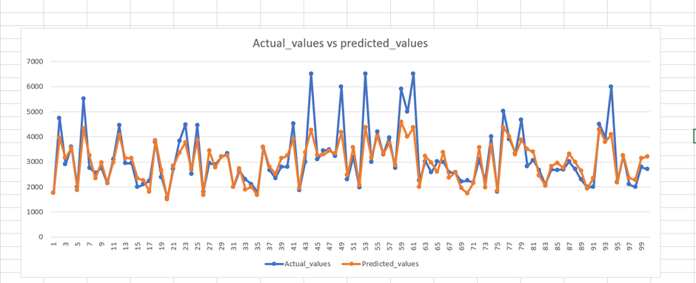

2. For 6 months Dataset (January to June):

Accuracy of the model: 71.7%

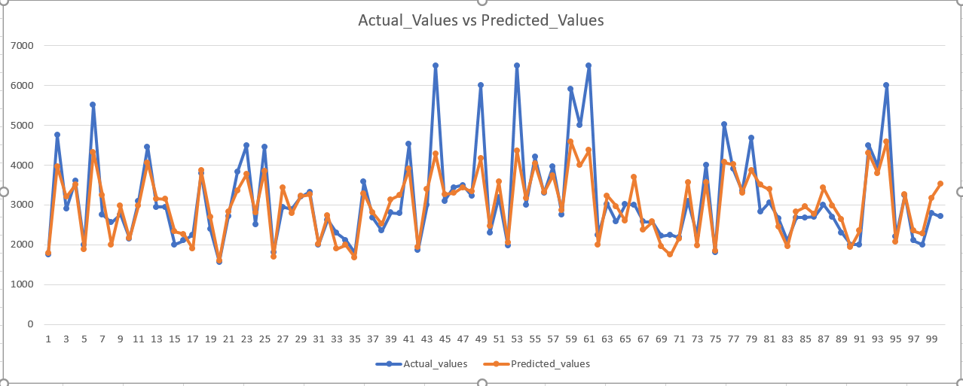

3 For 12 months Dataset (January to December):

Accuracy of the model: 70%

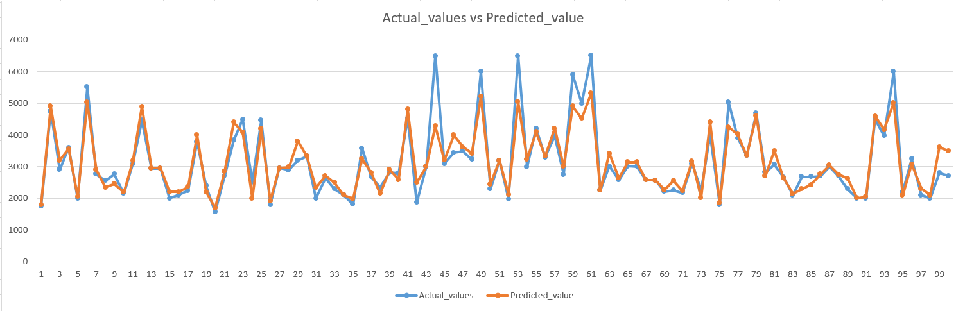

**Model 2:ARIMA**

The ARIMA (Auto Regressive Integrated Moving Average) model is a commonly used technique for time series forecasting. It combines autoregressive (AR), differencing (I), and moving average (MA) components to capture the patterns and dependencies in the time series data.

**Methodology:**

* Data Collection: Obtain historical data related to electricity prices in the West Bengal, Sikkim, Bihar, Jharkhand, and Odisha regions.
* Data Preprocessing: Perform data preprocessing steps to ensure the data is in a suitable format for analysis. This includes parsing dates, dropping missing values, and converting the time column to datetime format.
* Time Series Analysis: Convert the data into a time series by setting the "days" column as the index. This step helps in analyzing and forecasting the electricity prices over time.
* Resampling: Resample the data at an hourly frequency using the mean value within each hour. This step helps in aggregating the data and reducing noise for better analysis and forecasting.
* Visualization: Visualize the time series data by plotting it using the matplotlib library. This provides insights into the trends, patterns, and seasonality present in the electricity prices.
* Stationarity Testing: Perform the Augmented Dickey-Fuller (ADF) test to determine the stationarity of the time series data. The ADF test helps in assessing whether the data has a unit root, indicating non-stationarity, or is stationary.
* Model Selection: Utilize statistical techniques, such as autocorrelation plots and partial autocorrelation plots, to identify the suitable order parameters for an appropriate forecasting model. In this code snippet, a SARIMAX model with an order of (24, 1, 4) for 1 year, (23,1,0) for three months and (20,1,3) for 6 months is used.
* Model Fitting and Forecasting: Fit the selected SARIMAX model to the training data and generate forecasts for the test period. The predicted values are compared with the actual values to evaluate the accuracy of the forecasting model.
* Evaluation: Calculate the Root Mean Squared Error (RMSE) and Mean Absolute Percentage Error (MAPE) to assess the performance of the forecasting model. These metrics help in quantifying the forecast accuracy and determining the reliability of the model.
* Future Forecasting: Extend the forecasting horizon by generating future dates and using the fitted SARIMAX model to predict electricity prices for the upcoming time period.
* Visualization of Future Forecast: Plot the future forecasted prices along with the historical data to visualize the projected trends and patterns.
* Conclusion: Summarize the findings of the analysis, including the accuracy of the forecasting model, future price trends, and any insights gained from the analysis. This information can be utilized for decision-making in the electricity market, such as pricing strategies, resource planning, and risk management.

**Result:**

|  |  |  |  |
| --- | --- | --- | --- |
| **Duration** | **No. of Rows** | **rmse** | **mape** |
| January to March  (3 months) | 2160 | 1054.40 | 0.19 |
| January to June  (6 months) | 4344 | 1022.27 | 0.14 |
| January to December  (1 year) | 8760 | 428.77 | 0.07 |

**Graphs:**

Short term (3 months)

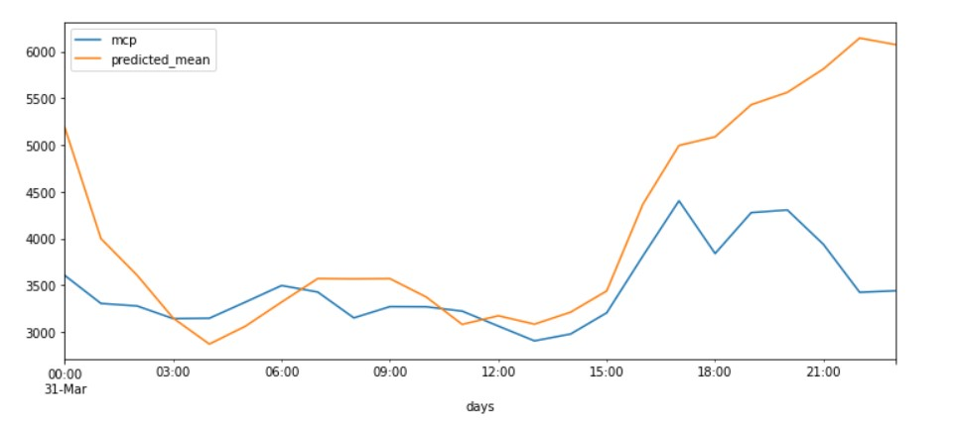

Graph 1: Test Data v/s Predicted Data

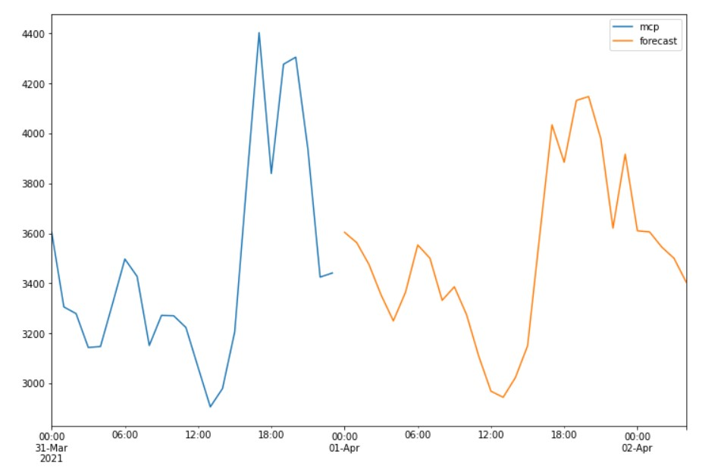

Graph 2: Forecasted Values from 2021-04-01 00:00:00 to 2021-04-02 04:00:00 with Test Data

Mid-term (6 months)

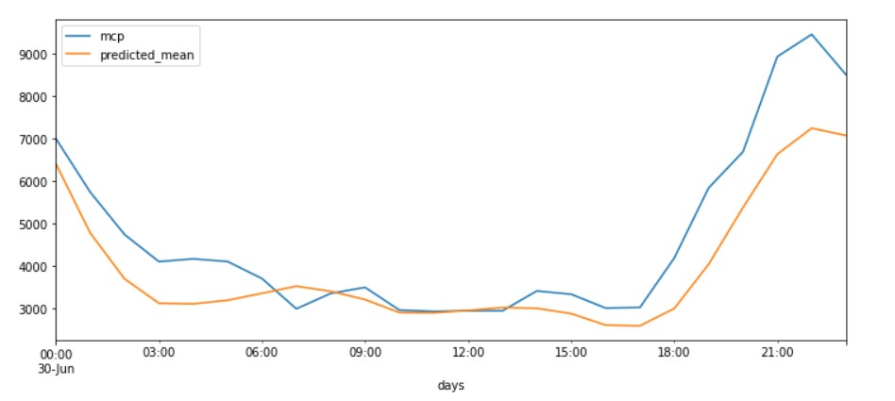

Graph 1: Test Data v/s Predicted Data

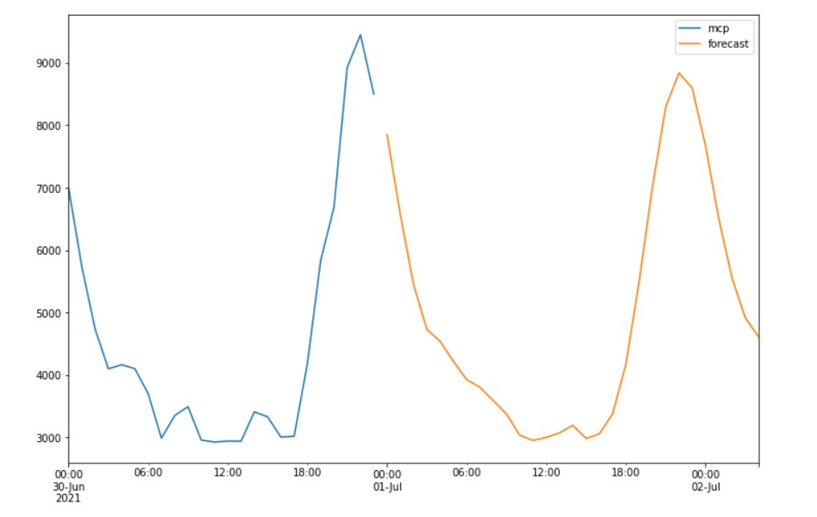

Graph 2: Forecasted Values from 2021-07-01 00:00:00 to 2021-07-02 04:00:00 with Test Data

Long-term (1 year)

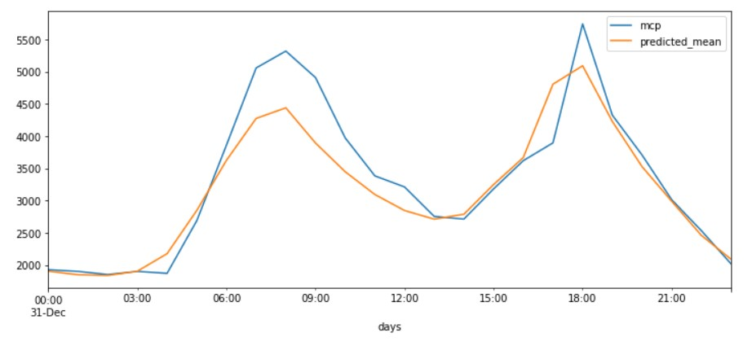

Graph 1: Test Data v/s Predicted Data

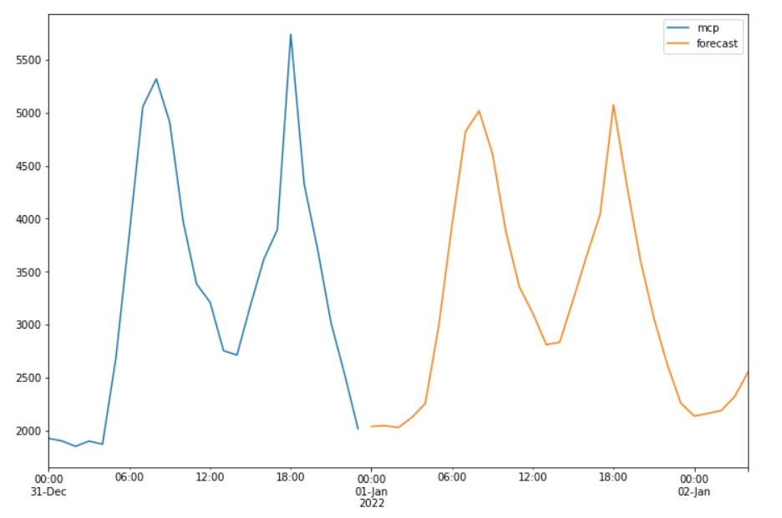

Graph 2: Forecasted Values from 2022-01-01 00:00:00 to 2022-02-02 04:00:00 with Test Data

**Model 3: LSTM**

* Long Short-Term Memory (LSTM) is a type of Recurrent Neural Network (RNN) that is commonly used for time series forecasting tasks, such as electricity price forecasting. The main advantage of LSTMs over traditional ANNs in this context is their ability to model and capture temporal dependencies and patterns in the data.
* Electricity prices are highly volatile and subject to fluctuations based on factors such as weather patterns, demand, and supply. The prices also exhibit time-dependent patterns such as seasonality, trends, and periodicity. LSTMs are well-suited to capture these temporal dynamics and learn the patterns that influence the prices.
* LSTMs achieve this by maintaining an internal memory state that can selectively store and forget previous inputs. This allows the network to remember important past information while filtering out irrelevant or redundant information. By doing so, the LSTMs can model the long-term dependencies and the short-term fluctuations in the data more effectively than traditional ANNs.
* In contrast, traditional ANNs treat each input independently, without considering the sequential dependencies between them. They are not designed to handle sequential data and can struggle to model temporal dynamics and long-term dependencies in the data.
* Therefore, LSTMs have an advantage over traditional ANNs in electricity price forecasting because they can better capture the temporal patterns and dependencies in the data. This can result in more accurate and reliable price forecasts.

**Methodology:**

1. Data Preprocessing:
   * Import the required libraries: numpy, pandas, sklearn.preprocessing, tensorflow.keras.models, tensorflow.keras.layers, matplotlib.pyplot.
   * Load the dataset using **pd.read_csv()** function, specifying the file path.
   * Inspect the dataset using **dataset.info ()** and **dataset.shape**.
   * Clean the dataset by dropping rows with missing values using **dataset.dropna()**.
   * Convert the 'time' column to datetime format using **datetime.strptime()** function.
   * Combine the 'date' and 'time' columns into a new 'days' column.
   * Set the 'days' column as the index of the dataset using **dataset.set_index('days')**.
   * Resample the dataset to hourly frequency using **dataset.resample('1H').mean()**.
2. Data Analysis:
   * Plot the dataset using **dataset.plot()** to visualize the time series data.
   * Conduct the Augmented Dickey-Fuller test for stationarity using the **adfuller_test()** function.
   * Plot the autocorrelation of the 'mcp' column using **autocorrelation_plot()**.
3. Data Export:
   * Export the updated dataset to a CSV file using **dataset.to_csv()**.
   * Download the CSV file using **files.download()** (assumes you are running in a Jupyter notebook environment).
4. Data Loading and Preprocessing for LSTM:
   * Import the required libraries: numpy, sklearn.preprocessing, tensorflow.keras.models, tensorflow.keras.layers.
   * Load the dataset from the exported CSV file using **np.genfromtxt()**.
   * Remove rows with NaN values using **~np.isnan(dataset).any(axis=1)**.
   * Split the dataset into train and test sets based on a specified ratio (e.g., 67% train, 33% test).
   * Scale the data using **MinMaxScaler** to transform the values to the range [0, 1].
5. LSTM Model Training and Evaluation:
   * Define the look-back window size and the number of features in the dataset.
   * Prepare the training data by creating input sequences and corresponding target values.
   * Prepare the testing data in a similar manner.
   * Build an LSTM model using **Sequential** and **LSTM** layers.
   * Compile the model with an optimizer and a loss function.
   * Train the model using the training data, specifying the number of epochs and batch size.
   * Make predictions on the training and testing data.
   * Calculate the root mean squared error (RMSE) to evaluate the model's performance.
6. Model Visualization:
   * Plot the training and validation loss using **plt.plot()**.
   * Plot the actual test values and predicted values using **plt.plot()**.
7. Price Prediction for Next Day:
   * Get the last 'look-back' days of data from the dataset.
   * Scale the input data using the same scaler used during training.
   * Reshape the input data to match the model's input shape.
   * Predict the price for the next day using the trained model and inverse transform the scaled prediction.
   * Print the predicted price for the next day.

**Results:**

|  |  |  |  |  |
| --- | --- | --- | --- | --- |
| **Duration** | **No. of Rows** | **Train rmse** | **Test rmse** | **(N+1) th**  **day price** |
| January to March  (3 months) | 2160 | 0.20 | 0.23 | 2903.363995 |
| January to June  (6 months) | 4344 | 0.14 | 0.11 | 2577.12554 |
| January to December  (1 year) | 8760 | 0.08 | 0.17 | 1817.33986 |

**Graphs:**

Short term (3 months)

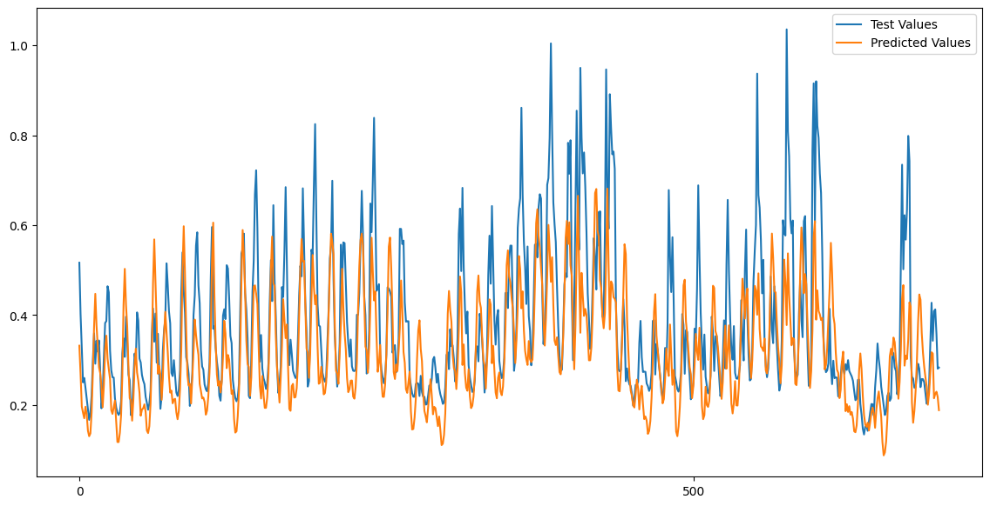

Mid-term (6 months)

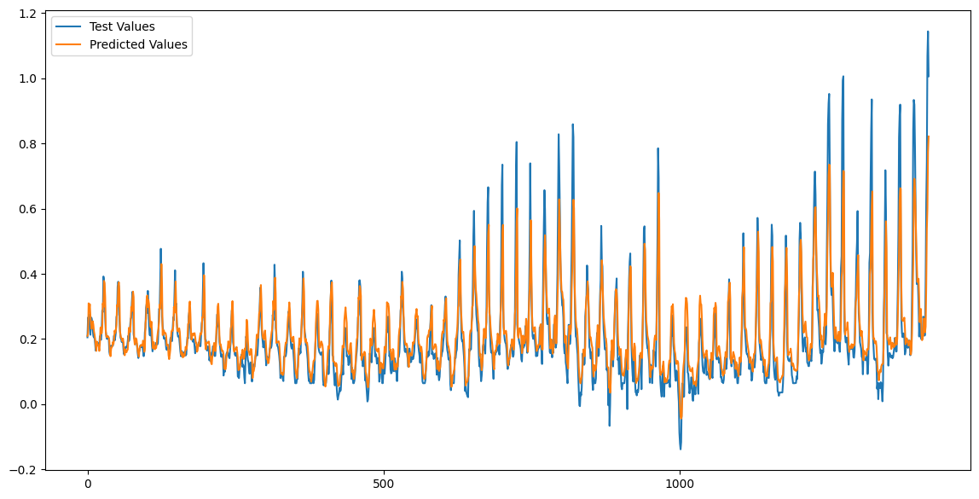

Long term (1year)

